Vulnerability of Peatland Carbon Stocks:

Expert Assessment Survey

Introduction
The goal of this survey is to use an expert assessment approach to determine the magnitude of changes in the peat carbon budget during: (a) the post-LGM (21000 BP-1750 AD), (b) the Anthropocene (1750-present), (c) the near future (present-2100 AD), and (d) the far future (2100-2300 AD). We are particularly interested in expert opinion regarding the relationship between a series of drivers and the peatland carbon budget that could lead to ‘surprises’ (i.e., possible thresholds and tipping points), since such non-linearity is difficult to predict on the basis of models. You will be asked to provide separate estimates of the peatland carbon budget for (a) tropical and (b) high-latitude peatlands. We request that you fill in both, whatever your expertise level, as we wish to identify where there is consensus of opinion and where there is greater uncertainty. You will be provided with the opportunity to let us know how confident you are for each one of your answers; if you have little or no expertise concerning a particular question, skip it and indicate your expertise level as 1 (see below).

We recognize that all the different components of peatland carbon dynamics are difficult to quantify and are not, and cannot be, precisely and definitively modeled or measured. As such, we are only asking for your informed opinion, realizing that some of the included parameters may not be well understood. By administering this survey to scientists with the most relevant expertise, we want to identify and evaluate the possible and probable magnitude of peatland fluxes.

Instructions
Please answer each question below for tropical and high-latitude peatlands. Immediately next to your answer, indicate your level of confidence and your expertise concerning your answer. Additionally, we ask you to provide comments pertaining to your approach on how you estimated the magnitudes of the carbon budget and/or key literature references in support of your view; this will allow us to compare responses from multiple experts. If the answer to a particular question is currently unknown, but there is a particular research direction that you think could resolve some of that uncertainty, please provide details in the “comments” space. If you have little or no expertise concerning a particular question, skip it and indicate your expertise level as 1.

The five-point “Confidence level” scale is defined as follows (see Table 1):

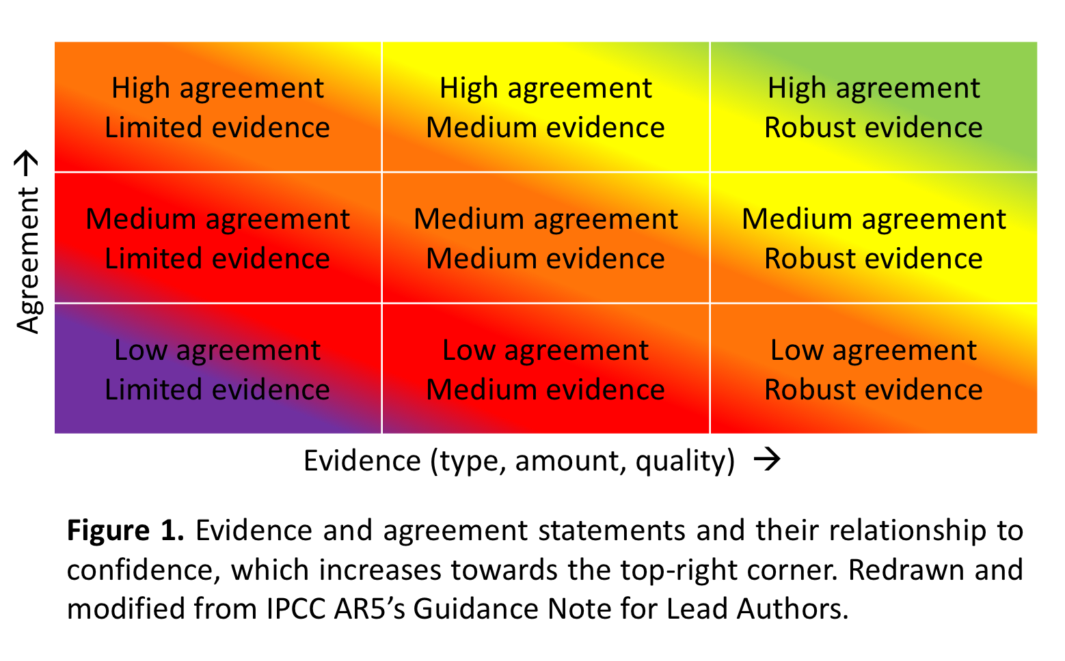
1 I have very low confidence in my answer; it is my best guess but it could easily be far off the mark. Scientific uncertainty on this issue is very large due to limited evidence AND low agreement.
2 I have low confidence in my answer; it is as good as anyone can offer at this time. Scientific uncertainty on this issue is large due to limited evidence OR low agreement.
3 I have medium confidence in my answer; it is as good as anyone can offer at this time. Scientific uncertainty on this issue is moderate. The true value is likely to be different from my answer.
4 I have high confidence in my answer; it is the best anyone can offer at this time. Scientific uncertainty on this issue is low due to robust evidence OR high agreement.
5 I have very high confidence in my answer and would be surprised if it was far off from the true value. Scientific uncertainty on this issue is very low due to robust evidence AND high agreement.

The five-point “Expertise level” scale is defined as follows:

1 I have no familiarity with the literature and I do not actively work on this particular question.
2 I have some familiarity with the literature and have worked on related questions but I haven't contributed to the literature on this issue; and I am not an expert on this question.
3 I am familiar with, and have contributed to, the literature in related topics, but I do not consider this issue to be central to my expertise; I have worked on related issues.
4 I have contributed to the relevant literature and have worked on this specific issue, but do not consider myself one of the foremost experts on this particular issue.
5 I contribute actively to the literature directly concerned with this issue, and I consider myself one of the foremost experts on it.

Feel free to share this survey with other peatland scientists who may not be C-PEAT members.

1. For high-latitude northern peatlands only (> 45N). How much cumulative peatland carbon release or uptake from the atmosphere is due to the different drivers during the different time periods (Gt Carbon absorbed or emitted as either CO₂, CH₄ or DOC). If you wish to comment on southern peatlands (> 45S), please do so using the space provided in Question 3. If you can’t quite isolate the role of each driver of change (e.g., temperature vs. moisture balance), please explain your answer in the “comments” space provided. Note that the average apparent carbon sink for the last millennium is ~ 0.14 Gt C per year for global peatlands (Gallego-Sala et al. 2018).
Driver | Post-LGM (21000 BP – 1750 AD) peatland flux (sink/source) |  |  | Anthropocene (1750 – present) peatland flux (sink/source) |  |  | Near Future (present – 2100) peatland flux (sink/source) |  |  | Far Future (2100 – 2300) peatland flux (sink/source)
 | Northern peatlands | Confidence Level (1-5) | Expertise Level (1-5) | Northern peatlands | Confidence Level (1-5) | Expertise Level (1-5) | Northern peatlands | Confidence Level (1-5) | Expertise Level (1-5) | Northern peatlands | Confidence Level (1-5) | Expertise Level (1-5)
Temperature | Sink =?Gt due to ? Source= ?Gt due to? Overall net sink =?Gt |  |  | Sink =?Gt due to ? Source =?Gt due to? Overall net sink =?Gt |  |  | Sink=?Gt due to ? Source=?Gt due to? Overall net sink =?Gt |  |  | Sink=?Gt due to ? Source=?Gt due to? Overall net sink =?Gt
Comments:
Key Literature:
Moisture balance
Comments:
Key Literature:
Sea level
Comments:
Key Literature:
Fire | Sink =?Gt due to ? Source= ?Gt due to? Overall net sink =?Gt |  |  | Sink =?Gt due to ? Source =?Gt due to? Overall net sink =?Gt |  |  | Sink=?Gt due to ? Source=?Gt due to? Overall net sink =?Gt |  |  | Sink=?Gt due to ? Source=?Gt due to? Overall net sink =Gt
Comments:
Key Literature:
Land-use
Comments:
Key Literature:
Permafrost
Comments:
Key Literature:
N deposition
Comments:
Key Literature:
Atmospheric Pollution
Comments:
Key Literature:

2. For lowland (sub-)tropical peatlands only (from 30N to 30S). How much cumulative peatland carbon release or uptake from the atmosphere is due to the different drivers during the different time periods (GT Carbon absorbed or emitted as either CO₂, CH₄ or DOC). If you wish to comment on montane peatlands, please do so using the space provided in Question 3. If you can’t quite isolate the role of each driver of change (e.g., temperature vs. moisture balance), please explain your answer in the “comments” space provided. Note that the average apparent carbon sink for the last millennium is ~ 0.14 Gt C per year for global peatlands (Gallego-Sala et al. 2018).
Driver | Post-LGM (21000 BP – 1750 AD) peatland flux (sink/source) |  |  | Anthropocene (1750 – present) peatland flux (sink/source) |  |  | Near Future (present – 2100) peatland flux (sink/source) |  |  | Far Future (2100 – 2300) peatland flux (sink/source)
 | Tropical peatlands | Confidence Level (1-5) | Expertise Level (1-5) | Tropical peatlands | Confidence Level (1-5) | Expertise Level (1-5) | Tropical peatlands | Confidence Level (1-5) | Expertise Level (1-5) | Tropical peatlands | Confidence Level (1-5) | Expertise Level (1-5)
Temperature | Sink =?Gt due to ? Source= ?Gt due to? Overall net sink =?Gt |  |  | Sink =?Gt due to ? Source =?Gt due to? Overall net sink =?Gt |  |  | Sink=?Gt due to ? Source=?Gt due to? Overall net sink =?Gt |  |  | Sink=?Gt due to ? Source=?Gt due to? Overall net sink =?Gt
Comments:
Key Literature:
Moisture balance
Comments:
Key Literature:
Sea-level
Comments:
Key Literature:
Fire | Sink =?Gt due to ? Source= ?Gt due to? Overall net sink =?Gt |  |  | Sink =?Gt due to ? Source =?Gt due to? Overall net sink =?Gt |  |  | Sink=?Gt due to ? Source=?Gt due to? Overall net sink =?Gt |  |  | Sink=?Gt due to ? Source=?Gt due to? Overall net sink =Gt
Comments:
Key Literature:
Land-use
Comments:
Key Literature:
N deposition
Comments:
Key Literature:
Atmospheric Pollution
Comments:
Key Literature:

3. Other comments. If you wish to provide additional comments on southern high-latitude peatlands, tropical montane peatlands, or peatland areas that were excluded above, or if you have any other comments, please do so here:

On behalf of the C-PEAT steering committee, we thank you for your answers. We will contact you in December with updated information.
Don’t forget to provide your name and email address in the online survey.

