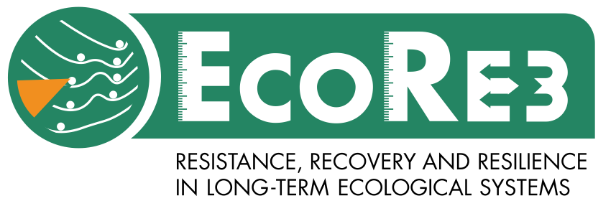

EcoRe3 Workshop 2
Call for Applications

University of Utah, Salt Lake City, Utah, USA 8-9 May 2018

Overview:
The next workshop for the PAGES working group EcoRe3 (www.pastglobalchanges.org/ini/wg/ecore3/intro) is in May 2018.
The topic of the workshop is ‘resilience, disturbance and functional traits’. We have an open call for a maximum of 30 participants to attend the workshop. The workshop will be split into two parts over two days. Part 1 will consist of a symposium with contributed talks from participants, giving a 20-minute talk in one of two different sessions (see below). EcoRe3 is planning a special issue based on the overall goals of the working group (see introduction on PAGES website for more information), and participants are encouraged to contribute papers to these talks which will go on to be submitted to this special issue (expected final submission date, Spring 2019). We aim that Part 1 of the workshop will be an opportunity for participants to critique and develop ideas for papers that will be contributed to this special issue. The two symposium sessions are as follows:
- Measuring resistance, recovery and resilience in long-term ecological datasets
- Linking functional traits and resilience in palaeoecology
Part 2 will consist of a series of breakout sessions to advance work in previous working group meeting focused on the broad topic of functional traits. Members of the working group will discuss how functional traits can be realistically reconstructed using palaeoecological data, and how functional traits might be expected to differ in systems that have higher resistance or slower recovery rates.
Applications:
All participants are asked to apply by 14th February 2018.
Some funding is available to support attendance of Early Career Researchers. Please indicate if you wish to be considered for this funding
Contact alistair.seddon@uib.no or jesse.morris3@gmail.com for more information.

Application form

Name:

Affiliation:

Early Career Researcher (Submitted PhD within the last 5-years) ☐
If you would like to be considered for funding support, please mark this box ☐

Abstract Title:

Proposed session:
Type to enter text
Abstract text (max 300 words):

