Challenges and opportunities for Paleo-informed ecosystem conservation in Asia

DiverseK workshop in Beijing, China
13-15th May, 2023

First Circular

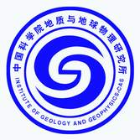
Introduction
The Local Organizing Committee in China and the PAGES DiverseK Working Group are pleased to welcome you to the DiverseK workshop on “Challenges and opportunities for Paleo-informed ecosystem conservation in Asia” in Beijing，China from 13-15 May 2023. This workshop involving thematic oral and poster sessions and an intra-meeting field trip, is designed with the following objectives:
1) the network development among paleoecologists and stakeholders in Asia with a common goal of effective ecosystem management;
2) the cross-comparison of management solutions under different national schemes within Asia; and
3) the identification of best conservation approaches in light of paleo-evidence from the respective regions.

This First Circular provides the details on the workshop program, organization, logistics, important dates, registration, and travel information. The Second Circular, including the Scientific Program and any last-minute logistical recommendations, will be distributed closer to the start of the workshop. The official language of the workshop will be English.

Workshop: 14-15 May 2023
The workshop will hold two overarching sessions, as highlighted below:

- Session I. Environmental policies and ecosystem management in Asia and around the world
This session will focus on the cross-comparison of management solution under different national schemes within Asia and those said to be successful ecosystem management practices outside of Asia that are based on multi-disciplinary approach merging the social and environmental sciences.

- Session II. Paleo-informed ecosystem conservation
This session will focus on sharing experiences from case-studies in Asia where conservation issues are tackled in different ways, drawing recommendations from paleo-data (e.g. conservation of dry steppe environments across Mongolia and China, forest management in different regions of Asia, fire management in human-dominated tropical landscapes, conservation of Pinus yunnanensis forest in Southwest China).

Outline of the Preliminary Program
Date | Time | Content
13 May  (Saturday) | 8:30 -21:30 | Registration
14 May  (Sunday) | 09:00-12:00 | Session I  (Oral presentations)
 | 12:00-13:00 | Lunch Time
 | 13:00-19:00 | Workshop trip  (Visit Zhoukoudian Site Museum)
15 May  (Monday) | 09:00-12:00 | Session II  (Oral presentations)
 | 12:00-13:00 | Lunch Time
 | 13:00-15:00 | Poster presentations  (Session I & II)
 | 15:00-17:00 | Discussions & Common view  (Session I & II)
 | 18:00-21:30 | Downtown Tour

Registration Information
For timely planning of the workshop, all attendees are requested to finish their Registration before 10 April, by sending the workshop receipt (Form) to us (qiaoyu.cui@igsnrr.ac.cn).

Registration Fee
There is no registration fee.

Financial Support
We have a budget awarded by PAGES and NSFC to cover a limited number of travel and accommodation awards for international participants, including early-career researchers and invited speakers (PAGES funds particularly), and domestic participants (priority will be given to graduate students and post-doctoral fellows).

The awards are not intended to cover all your expenses, except under special circumstances. We ask you make a reasonable estimate of the requested amounts based on your situation (e.g. travel distance). The upper financial limits are set as 1500 US dollars for travel. Please send your CV, copy of workshop abstract, a short 250-word statement explaining why you would like to attend the workshop, and how it is relevant to your research, and the estimates of travel expenses to Qiaoyu Cui (qiaoyu.cui@igsnrr.ac.cn) by 27 March, 2023. Please note that all expenses must ultimately be accounted for with receipts.

The selection of the awardees will be performed by the local Organizing Committee in China and the PAGES DiverseK Working Group. The successful candidates will be informed via email by 31 March, 2023.

Call for Abstracts.
We welcome contributions from the paleo-environmental community as well as local stakeholders from different regions of Asia interested in applying long-term ecological knowledge in ecosystem conservation. The contribution and knowledge exchange from neighboring areas within Asia is essential to achieve the objectives of the workshop.

Details on abstract submission
All abstracts must be written in English, in plain text without any special characters. The Word limit is 350, excluding titles, author names, and affiliations. No references should be included. Graphics will not be accepted.

All abstracts must be sent to Qiaoyu Cui (qiaoyu.cui@igsnrr.ac.cn) before 20 April, 2023. The acceptance of abstracts will be communicated before 30 April, 2023.

Important Dates
- First circular: 8 March
- Travel grant application deadline: 27 March
- Notification travel grant awardees: 31 March
- Abstract submission deadline: 24 April
- Deadline of registration and confirmation of participation: 30 April
- Second circular with final program: 8 May
- Workshop dates: 13-15 May 2023

Organizing Committee
- Qiaoyu Cui, Institute of Geographic Sciences and Natural Resources Research (CAS), China (qiaoyu.cui@igsnrr.ac.cn); Steering Committee (SC) of DiverseK
- Liping Zhou, Peking University, China (lpzhou@pku.edu.cn); Executive Committee of PAGES
- Yiyin Li, Peking University, China (Lyy@urban.pku.edu.cn); SC of International Paleofire Network (IPN)
- Jing Wu, Institute of Geology and Geophysics (CAS) , China (wujing@mail.iggcas.ac.cn); members of DiverseK
- Ming Ji, Yuxi Normal University, China (jiming06@mails.ucas.ac.cn); members of DiverseK
- Charuta Kulkarni, Independent Researcher, India (ckulkarni@gradcenter.cuny.edu); SC of DiverseK
- Estelle Razanatsoa, University of Cape Town, South Africa (estellebota@gmail.com); SC of DiverseK

Scientific Committee
- Qiaoyu Cui, Institute of Geographic Sciences and Natural Resources Research (CAS), China; SC of DiverseK
- Charuta Kulkarni, Independent Researcher, India; SC of DiverseK
- Estelle Razanatsoa, University of Cape Town, South Africa; SC of DiverseK
- Michael Coughlan, University of Oregon, USA; SC of DiverseK
- Jay Mistry, RHUL, UK; SC of DiverseK
- Copes-Gerbitz, Faculty of Forestry, University of British Columbia, Canada; SC of DiverseK
- Liping Zhou, Peking University, China; Executive Committee of PAGES
- Yan Zhao, Institute of Geographic Sciences and Natural Resources Research (CAS), China
- Yiyin Li, Peking University, China; SC of IPN
- Jing Wu, Institute of Geology and Geophysics (CAS), China; members of DiverseK
- Ming Ji, Yuxi Normal University, China; members of DiverseK

Sponsors
National Natural Science Foundation of China
Past Global Changes (PAGES)
Zhoukoudian Site Museum
General information
Conference Venue
The conference will be held in room 301AB, China National Convention Center, Beijing, China. Sessions will take place in a meeting equipped with video projectors that can link to PC. Furthermore, an online meeting will be available during the meeting, i.e. 09:00-12:00 on 14 and 15 May. More details of the online meeting will be delivered in the 2nd Circular.
Meeting Address: No.7 Tianchen East Road, Chaoyang District, Beijing, China

Accommodation

The accommodation will be arranged at the China National Convention Center Grand Hotel (4-star), located in the central area of the Olympic Park and 0.1 km away from the conference venue. Rooms of different types have been reserved with discount rate for conference participants. The address of the hotel is Building 1, No. 8 Precincts, Beichen West Road, Changyang District, Beijing, China. For more detailed information, please visit the website the hotel webpage:

Information on the workshop trips

Zhoukoudian Site Museum
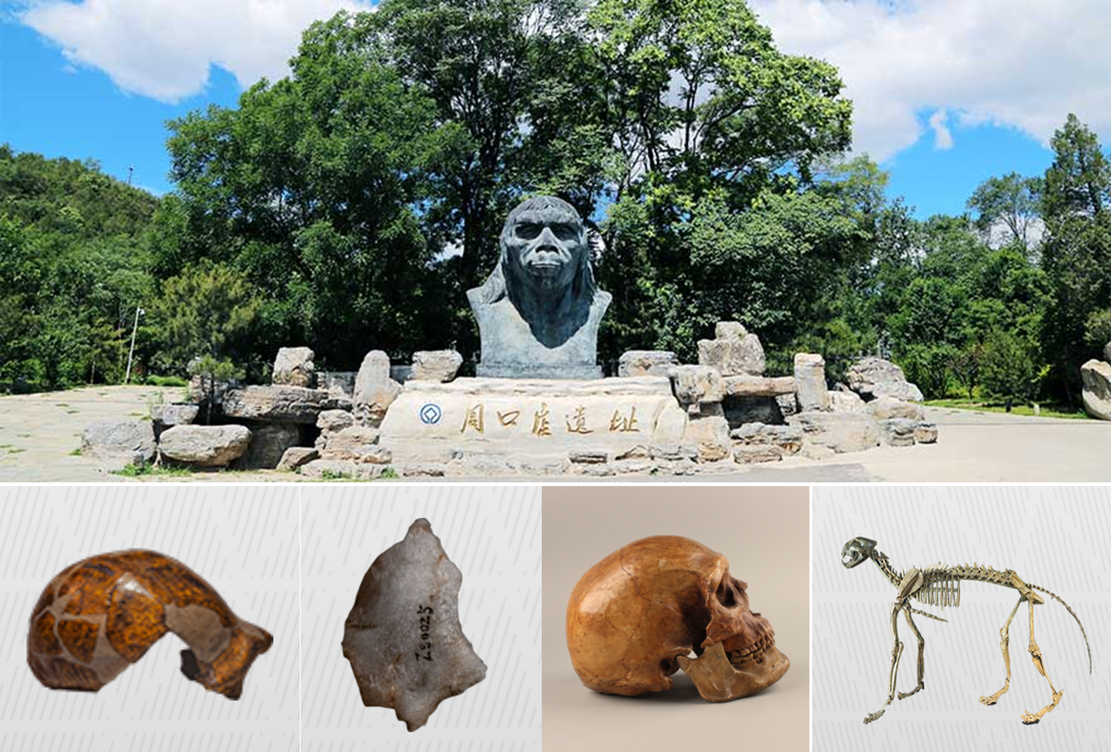
The ruins of Zhoukoudian are located in Fangshan District, about 50 kilometers southwest of Beijing, backed by the undulating Taihang Mountains, facing the vast North China Plain, is the place where the "Beijing people" lived between 700,000 and 200,000 years ago, the fourth site of early Homo sapiens 200,000 to 100,000 years ago, the pastoral cave people about 4.2-38,500 years ago, and the mountaintop cave people about 30,000 years ago. A total of 27 sites of various fossils and cultural relics of different periods have been found at the Zhoukoudian site, and more than 200 human fossils, more than 100,000 stone tools, a large number of fire relics and hundreds of animal fossils have been unearthed, becoming a world-famous treasure of human fossils and a multidisciplinary comprehensive research base for paleoanthropology, archaeology, paleontology, stratigraphy, chronology, environmental science and karst.

Beijing Downtown in May
A night tour to the Beijing (BJ) downtown will be organized during the workshop. The visit route will offer you to experience the urban glamour of BJ from parts of the new BJ (Olympic part) and old BJ (Yandaixiejie Hutong, one of the most age-old streets in BJ). The guides will be the volunteers from local organization committees. More information about this tour will be released during the workshop.

Fees for workshop trips
There are no fees for workshop trips.

Letter of Invitation
Requests for formal letters of invitation to attend the DiverseK workshop in Beijing should be directed to Qiaoyu Cui (qiaoyu.cui@igsnrr.ac.cn). This invitation is intended to assist participants in travel and visa arrangements and does not imply financial support.
Workshop Receipt

Last Name
First Name
Sex
Country
Affiliation
Phone
Email
Abstract Submission | YES ( ) NO ( )
Title of Abstract
Presentation | Oral ( ) Poster ( ) Attend ( )
Title of presentation
Application for Financial Support | YES ( ) NO ( )
Travel  (planed) | Arriving date：  Leaving date：
Travel by:
Flights ( ) Trains ( )
Hotel reservation service | Need ( ) No needs ( )
Invitation letter | Need ( ) No needs ( )

