First Circular

IVX Subfossil Cladocera Workshop,
Levico Terme (Italy), Hotel Cristallo, April, 5th-8th 2016.

Dear subfossil Cladocera specialists,

we are happy to invite you at the IVX Subfossil Cladocera Workshop, which will take place at Levico Terme, a small thermal town located at the shore of Lake Levico in the Autonomous Province of Trento (http://www.visitvalsugana.it/en/places/levico-terme).

The Subfossil Cladocera Workshops are informal international meetings of people working with subfossil remains of Cladocera in lake and wetland sediments. Participants discuss methodological, taxonomical, and ecological aspects of subfossil Cladocera research, and present their ongoing work, having microscope sessions and teaching to young scientists.

Following a well-established tradition, also the next workshop will be a compact and a low cost event, aimed at attracting the participation of students and young researchers from Europe and outside. Thanks to the co-funding by the International Research School in Applied Ecology (IRSAE, http://www.irsae.no), students from institutions affiliated to the IRSAE consortium will receive full board refunding for three overnight stays (i.e. April, 5th-7th). In late autumn 2015 there will be the possibility to apply for a further (small) funding by the Autonomous Province of Trento, which, in case of success, might further contribute to reduce the participation costs.

The Workshop will be organized as a resident event with all in-house facilities at Hotel Cristallo (http://www.hotelcristallotrentino.it) and the related Granì Aaritz, which is 100 m away from the hotel. The rooms at the Garnì will be is reserved for students’ accommodation, included those from the IRSAE consortium. Full board will be provided for all participants at Hotel Cristallo.

Full board accommodation, workshop dinner and excursion are on participants’ own expenses. An exception is represented by the IRSAE students, whose accommodation costs and workshop dinner will be completely covered by the workshop organization.

The workshop is free, but a maximum of 50 participant can attend. So we kindly ask you to complete the attached pre-registration form and to send it to the organizing committee, in order to facilitate the next organizing steps. In the case more people respond with a pre-registration form, a waiting list will be initiated.
Workshop registration will be opened in late summer 2015.

Preliminary workshop programme:

Tuesday, April 5th: arrival at Hotel Cristallo, Levico Terme, participant registration, ice-breaker dinner.

Wednesday, April 6th: participant registration, IVX Cladocera Workshop opening, oral session, plenary lecture 1, lunch, plenary lecture 2, poster session, dinner.

Thursday, April 7th: Microscopy session, 2/3 day excursion (with packed lunch), social dinner.

Friday, April 8th: oral session, poster session, lunch, closing session, check out.
Invited speakers:

1 - Marina Manca, ISE-CNR, Verbania-Pallanza, Italy

2 - Marie-Elodie Perga, French National Institute for Agronomical Research, Thonon les Bains, France

Excursion:

A half day excursion will be organized to the southern part of Lake Garda, which, beside a mild climate, offers the possibility to combine beautiful cultural and natural sightseeing. During the excursion the past and recent paleo- and neo-limnological research activities conducted on Lake Garda by the Limnology and River Ecology Group of FEM will be illustrated.
Excursion fees are not yet defined, as depending from the final number of participants.

Social dinner:

The workshop dinner will take place at a brand new restaurant in Levico Terme (Fabbrica di Pedavena, http://www.b612hotel.com) within walking distance from Hotel Cristallo, and is intended as in informal and easy get together, with regional food and beers. Dinner costs will be around 30,00 Euro per person.

Workshop proceedings:

It is our intention to publish the workshops acts as a special issue of o peer reviewed international scientific journal, especially in order to promote the publication of research by PhD students and younger researchers. We are currently collecting information from some international journals, and evaluating the editing and publishing costs.

Travel information:

Levico Terme is about 20 Km (ca. 15 by car on the freeway) away from Trento, the main town of the Trentino Province. Trento and Levico are connected by high frequency busses (http://www.ttesercizio.it/Extraurbano/Valsugana.aspx) and local trains (www.trenitalia.it).

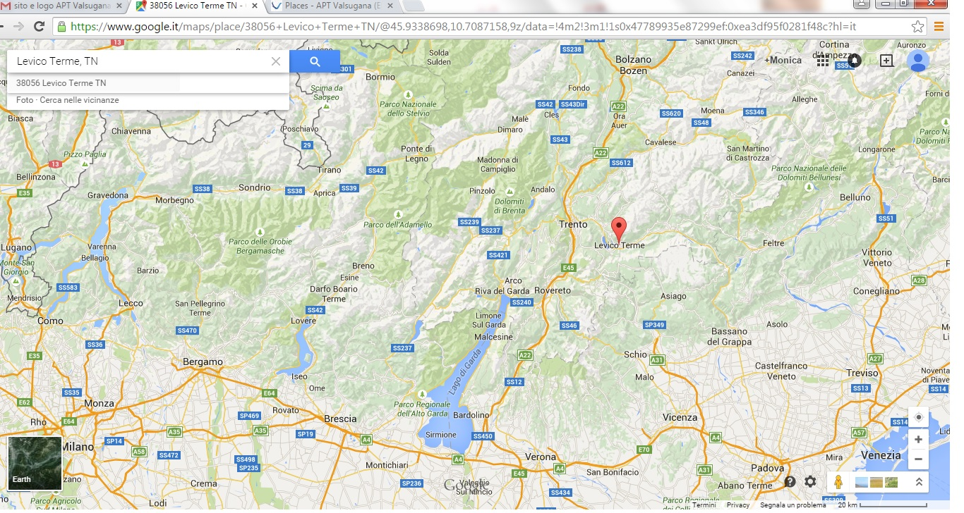
Trento can be reached:

By car: through the motorway A22 Brennero-Modena (http://www.autobrennero.it)

By train: trenitalia.it

By plain: the closest international airports are Verona-Villafranca (www.aeroportoverona.it), Venice (www.veniceairport.it), Bergamo Orio-Alserio, which is very convenient for Ryanair flights, and Milan-Linate (www.milanolinate.eu/it).
As all these airports are connected to Trento via Verona, it our intention to organize a transportation from the main train station of Verona directly to Hotel Cristallo in Levico Terme on April, 5th afternoon. The transfer will take about 2 hours. Further information will be provided by the next circulars.

Further information on transport are available at the tourist web age of Valsugana: http://www.visitlevicoterme.it/it/details-articles/con-i-trasporti-pubblici/78/

Please, feel free to distribute this message to anyone who might be interested in participating.

Looking forward meeting you at Lake Levico!
With best wishes,

The organizing committee:

Monica Tolotti (monica.tolotti@fmach.it)
Manuela Milan (manuela.milan@fmach.it)
Nico Salmaso (nico.salmaso@fmach.it)

